Web 2.0 Technologies in High School Curriculum: Exploring the Culture of Media, Health and Literacy in Myanmar

Christine Beer
Department of Curriculum and Instruction
University of Victoria
Canada
cmbeer@uvic.ca

Abstract: This paper is a report on a newly initiated project to examine how the concept of Critical Media Health Literacy functions in a high school curriculum. The population of focus is high school students in one school setting in Yangon, Myanmar. The school’s mission states that critical thinking strategies across subjects, the development of healthy lifestyles, and the role of technology in student learning are valued components of the curriculum. The purpose of this report is to discuss the newly initiated project from the perspectives of how Web 2.0 technologies are used in the curriculum process to support the participatory action research design, how social media will be used for engaging youth about the cultures of media and health, and the potential for partnering with other researchers in the field.

Introduction

People around the world are increasing their use of media content and digital information and communication technologies for evaluation and communication of health issues. Literacy is key to this process. Literacy is more than reading and writing. In the areas of media and health, literacy is how the individual reads, views, hears—and then critiques, analyzes, communicates and acts on the health information presented as media and through media communications. Previous research has shown that a person’s evaluation and communication of health information and resulting health behaviour is related to the person’s literacy in health and media (Alpay, Verhoef, Bo, Te'eni & Zwetsloot-Schonk, 2009; Begoray & Bannister, 2005; Begoray, Wharf Higgins, & MacDonald, 2009; Begoray, Cimon & Wharf Higgins, 2010; Begoray, 2011; Bergsma, 2004; Berkman, Davis & McCormack, 2010; Kickbush, 2001; Kickbush, 2007; Keselman, Logan, Smith, Leroy & Zeng-Treitler, 2008; Levin-Zaamir, Lemish & Gofin, 2011; Lupiáñez-Villanueva, Angel Mayer & Torrent, 2009; Nobel 2006; Marschollek, Mix, Wolf, Effertz, Hauxi & Stienhagen-Theissen, 2007; McCray, 2010; Nutbeam, 2000; Nutbeam, 2008; Perry & Weldon 2005; Zarcadoolas, Pleasant & Greer, 2005).
Little is known about the skills in critical literacy, health literacy, and media literacy of high school students in Myanmar. In addition, there is a lack of research about the relationship of critical, health and media literacies to Myanmar students’ health promoting behaviours. Health promoting behaviours are the abilities of high school students to understand health and media information and use the information to act in ways that improve their health. Finally, there is a lack of research about the health issues faced by Myanmar high school students. Based on health care projects conducted in Southeast Asia, it is known that adolescents in that geographical area face three significant health risks. Three of the top health priorities for high school age students in Southeast Asia are reproductive health promotion, HIV prevention, and improved mental health as related to reproductive health (WHO 2008; WHO, 2010; WHO 2011). There is a lack of knowledge, generally, about the health and the relationship between literacy and health status in high school students situated in Myanmar..
The theoretical concept which will be examined in this study is Critical Media Health Literacy (Begoray, Cimon & Wharf Higgins, 2010; Begoray, 2011). This concept brings together the concepts of health literacy (Nutbeam, 2000), media literacy (Hobbs & Frost 2003; Hobbs, 2004), and critical literacy (Friere, 1973). Critical Media Health Literacy is a concept which attempts to describe the effects of media modes and messages on an individual’s health beliefs and behaviors (Begoray, Cimon & Wharf Higgins, 2010; Begoray, 2011). Research has shown that high school students’ ability to critically interact with media is important to the ways that the students act in situations that impact their health (Begoray, Cimon & Wharf Higgins, 2010; Levin-Zamir, Lemish, Gofin, 2011).
Given the lack of research with high school students in Myanmar, this research project will examine how students’ interactions with digital media content and Web 2.0 technologies are related to the students’ literacy in the content areas of media and health. In addition, this research project will examine how students carry out purposeful actions for the benefit of their own health.

Theoretical Rationale

Critical literacy is a way of thinking with language that can affect one’s sense of critical consciousness for being, knowing, and acting in the social contexts which situate one’s life experiences (Friere, 1973). A person’s life experiences are performed, whether consciously or subconsciously, in many social contexts, such as family, school, and mediated digital communications. These performances form habits through repeated actions in symbolic environments in which a person solves problems of beliefs and behaviours, and “the problem-solving component can be expected to form the habit of critical or hypothetico-deductive methods of reasoning in social and individual problem situations” (Broudy, 1981).
Critical Media Health Literacy bridges the domains of media and health (Begoray, Cimon, Wharf-Higgins, 2010; Begoray, 2011) in a theoretical concept that seeks to explain the power and practice of literacies to consciously interact with ideas and processes in society and through media. The theory emphasizes empowerment for critiquing factors that influence health beliefs and behaviours, for the purpose of acting on changes that promote health (Figure 1).

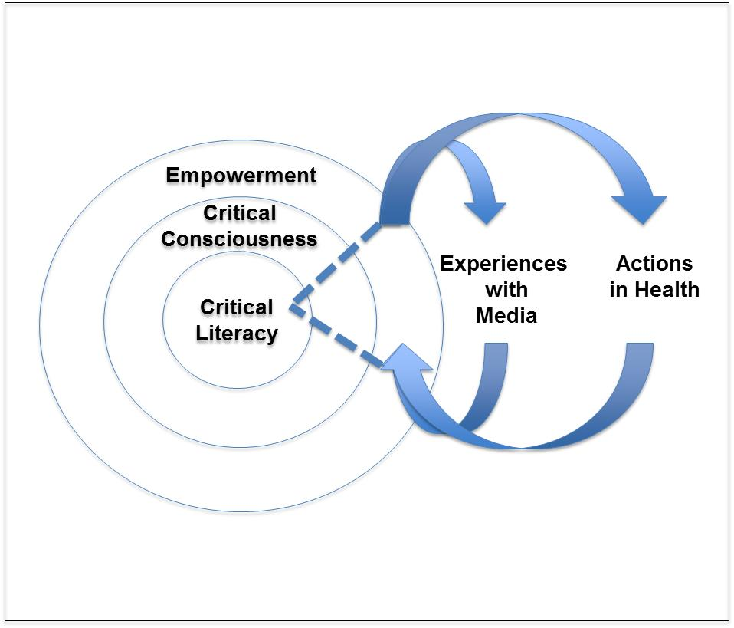

Figure 1: Critical Literacy is Key to Empowered Actions with Media and in Health

Research on adolescents’ Critical Media Health Literacy needs to accommodate the increasing use of digital technology by adolescents (Kickbusch, 2001) as that use pertains to the evolving concepts of health literacy, ‘media health literacy’ (Levin-Zamir et al., 2011), critical media health literacy (Begoray, 2011, Begoray, Cimon & Wharf Higgins, 2010) and health promotion. English language arts research has indicated that “[t]hrough digital spaces learners and teacher stretched their traditional relationships with [the curriculum], their idea of classroom and each other” (Nahachewsky and Slomp, 2009, p. 146). By situating the proposed participatory action research study in digital spaces and as part of the curriculum process, the high school students will be engaged with other students to consider their health beliefs and behaviours, as well as the influences of Critical Media Health Literacy on those health beliefs and behaviours.

The Participatory Action Research Project

The purpose of this research project is to contribute to new knowledge about how Myanmar high school students’ use of digital media content and Web 2.0 technologies influences health literacy and ultimately health through what is termed ‘critical media health literacy’. Given the lack of research about how high school students in Myanmar develop capacities for critical media health literacy, the participatory action research project will explore two questions. How does the theoretical concept of Critical Media Health Literacy work in a high school curriculum practice set in Myanmar? How is Critical Media Health Literacy present in this population? As participants in the research, high school students will choose a health issue relevant to the entire group of study participants, and then the participants will work together on a digital media project to explore, discuss, and take action on the health issue.
The intent of the project is to develop an understanding of how the theoretical concept of Critical Media Health Literacy works in a high school curriculum process and how a curriculum process designed on that concept affects the particular way the students develop abilities for critical analysis of digital media related to health issues. In addition, this project is intended to create a local understanding of this phenomenon and improve the design of curriculum processes which promote critical literacy, media literacy, health literacy, and health outcomes for high school students situated in Myanmar.

Technologies for the Digital Media Project

The participatory action research project is in its initiation stage and the task at hand is finding, choosing, and setting up technologies for the digital media project. The digital media project will be designed by the students and will require software and hosting for web pages. The web pages will be used to present multi-media information, allow for collaboration in the development of content, and facilitate online communication amongst the students and teachers. Although these functional requirements could be met with products such as Facebook and Blogspot, the situation of the study and ethics protocol for the research add requirements which override the functional ones.
The practical aspects of finding and employing Web 2.0 technologies, such as social media, for ethical classroom use hinge on two points. First, the research ethics protocol calls for web hosting to be in Canada, so the students’ confidentiality and privacy can be protected. If the research activities use a product which is hosted in the US, then the privacy and confidentiality of student-generated content could be compromised by activities which may be authorized by the US Patriot Act. Approximately 90% of the students are Burmese and many are from families with family or business connections to the Myanmar government. Many student use Facebook and other Web 2.0 technologies hosted on servers in the US, however, Facebook would not be an appropriate Web 2.0 technology for this project due to the educational research nature of the project, the need to protect privacy and confidentiality of student-generated data, and to the fact that content will be generated based on a curriculum process and research questions partially directed by the researcher who is also a teacher of the student participants. Use of Web 2.0 technologies provided on servers located in the US could cause unecessary tensions and complications for research participants and for the ethical protocol of the research study.
Second, the school’s Internet services are unreliable and usually very slow. For example, Internet is inaccessible at least once per day for varying periods of time, from a few minutes to 6 hours so far in this academic year. Another issue is that a simple webpage, such as a Gmail message in Basic HTML mode, often takes several minutes to load. Software and hosting of the content and communication for the digital media project needs to be scaled to deal with the low performance of the school’s local area network and Internet speed, and there must be a back up plan for hosting the digital projects on the school’s servers if the Internet services are not sustaining students’ needs during the digital media project. The challenge is to minimize the risk of the technology being restrictive in terms of performance or framework to the point that technology gets in the way of the research activities.
These and other issues related to the selection and use of Web 2.0 technologies will be discussed during the Global TIME 2012 virtual presentation. Issues will be discussed as they relate to the the following activities of the participatory action research study:

- Development of individual web pages to explore the chosen health issue and its practical solution
- Set up and use of online (web log) group discussions shared by students and teachers
- Data Collection
  - Recording of digital multi-media text (e.g., video, audio, photo, written texts) created by students about the health issue
  - Recording of online discussions and the students’ web pages
- Data Analysis
  - Qualitative Data
    - Identification of key elements emerging from the data
    - Formulation and grouping of categories for the key elements
    - Coding of data items by one or more categories
    - Identification of significant items of information
    - Formulation and grouping of themes
(Stringer, 1999, cited in Creswell, 2007).
  - Quantitative Data
    - Counting of specific findings
    - Determining significance of count results
    - Examinng whether the findings are typical, rare, or extreme
(Gall, Gall & Borg, 2010).

The intent of this participatory action research project is to develop an understanding of how the concept of Critial Media Health Literacy works in a high school curriculum. In addition, the research will explore how the concept of Critical Media Health Literacy relates to the students’ motivation and abilities to develop literacies needed for the complex system of interconnected content and communication elements on the Web. The goal is to affect the curriculum processes which faciliate the development of high school students’ critical capacities of media literacy, health literacy, and motivation and abilities to solve problems of belief and behaviour that impact the students’ health.

References

Alpay, L., Verhoef, J., Bo, X., Te'eni, D., & Zwetsloot-Schonk, J. (2009). Current challenge in consumer health informatics: Bridging the gap between access to information and information understanding. Biomedical Informatics Insights, 2, 1-10.
Begoray, D., Bannister, E. (2005). Using curriculum design principles to improve health education for adolescent girls. Health Care for Women International, 26, 295-307.
Begoray, D., Wharf Higgins, J. & MacDonald, M. (2009). High school health curriculum and health literacy: Canadian student voices. Global Health Promotion 16(4), 35-42.
Begoray, D., Cimon, M., & Wharf Higgins, J. (2010). Mediating health: The power and role of the media. New York, NY: Nova Science Publishers, Inc.
Begoray, D. (2011). PowerPoint slides presented at the 2011 conference of the National Association for Media Literacy Education (NAMLE) in Philadelphia, Pennsylvania. Retrieved from http://namle.net
Bergsma, L. (2004). Empowerment education: The link between media literacy and health promotion. American Behavioral Scientist, 48(2), 152-164.
Berkman, N., Davis, T., McCormack L. (2010). Health literacy: What is it? Journal of Health Communication, 15(1), 9-19.
Broudy, H. (1982). What knowledge is of the most worth? Educational Leadership, 39(8), 574-578.
Creswell, H. R. (2007) Educational research: Planning, conducting and evaluating quantitative and qualitative research (3rd ed.) New Jersey: Pearson Education.
Freire, P. (1973). Education for critical consciousness. New York, NY: Continuum Publishing Company.
Gall, M.D., Gall, J.P., Borg, W.R. (2010) Applying educational research: How to read, do, and use research to sole problems of practice (6th ed.) Boston, MA: Pearson Education.
Hobbs, R. & Frost, R. (2003). Measuring the acquisition of media literacy skills. Reading Research Quarterly, 38(3), 330-355.
Hobbs, R. (2004). A review of school-based initiatives in media education. American Behavioral Scientist, 48. 42-59.
Keselman, A., Logan, R., Smith, C., Leroy, G., & Zeng-Treitler, Q. (2008). Developing informatics tools and strategies for consumer-centered health communication. Journal of the American Medical Informatics Association, 15 (4), 473-83.
Kickbusch, I., (2001). Health literacy: Addressing the health and education divide. Health Promotion International, 16(3), 289-297.
Kickbusch, I., (2007). From policy and practice to beyond. Canadian Council on Learning. Retrieved from http://www.ccl-cca.ca/NR/rdonlyres/ED97299E-46AF-429E-9EAE-55AE806ECD2D/0/HLKCSymposiumReport07.pdf
Levin-Zamir, D., Lemish, D.,& Gofin, R. (2011). Media health literacy (MHL):Development and measurement of the concept among adolescents. Health Education Research, 26(2), 323-335.
Lupiáñez-Villanueva, F., Angel Mayer, M., & Torrent, J. (2009). Opportunities and challenges of Web 2.0 within the health care systems: An empirical exploration. Informatics for Health & Social Care, 34 (3), 117–126.
Marschollek, M., Mix, S., Wolf, K., Effertz, B. Hauxi, R., & Stienhagen-Theissen, E. (2007). ICT-based health information services for elderly people: Past experiences, current trends, and future strategies. Medical Informatics and the Internet in Medicine, 32 (4), 251-261.
McCray, A. (2010, July 2) Consumer Health Informatics: Evidence-based decision making by patients and families. Powerpoint lecture presented at the Marine Biology Laboratory in Woods Hole, New Hampshire. Retrieved from courses.mbl.edu/mi/2010/presentations_spring/ConsumerInformatics.ppt
Nahachewsky, J. & Slomp, D. (2009). Sound and fury: Studied responses of curriculum and two classrooms in digital times. In Nahachewsky, J. & Johnson, I. (Eds). Beyond presentism: Re-imagining the historical, personal and social places of curriculum. Rotterdam, Netherlands: Sense Publishers.
Nobel, J. (2006). Bridging the knowledge–action gap in diabetes: information technologies, physician incentives and consumer incentives converge. Chronic Illness, 2, 59-69.
Nutbeam, D., (2000). Health literacy as a public health goal: a challenge for contemporary health education and communication strategies into the 21st century. Health Promotion International, 15(3), 259-267.
Nutbeam, D., (2008). The evolving concept of health literacy. Social Science & Medicine 67, 2072-2078.
Perry, G., Weldon, S. (2005). Consumer health informatics research: implications for consumers, health information professionals, and researchers. Journal of Consumer Health on the Internet, 9 (2), 1-10.
Stringer, E. T. (1999). Action research. New York, NY: Sage Publishing.
World Health Organization (WHO). (2007). 10 facts on adolescent health. Retrieved August 11, 2011, from http://www.who.int/features/factfiles/adolescent_health/en/index.html
World Health Organization (WHO). (2010). World Health Statistics report. Retrieved August 11, 2011, from http://www.who.int/whosis/whostat/en/
World Health Organization (WHO). (2011). Reproductive Health. Retrieved August 11, 2011, from http://www.who.int/topics/reproductive_health/en/
Zaracadoolas, C., Pleasant, A., & Greer, D. (2005). Understanding health literacy: An expanded model. Health Promotion International, 20 (2), 195-203.

